**TOWS Analysis**

Report for Human Resources

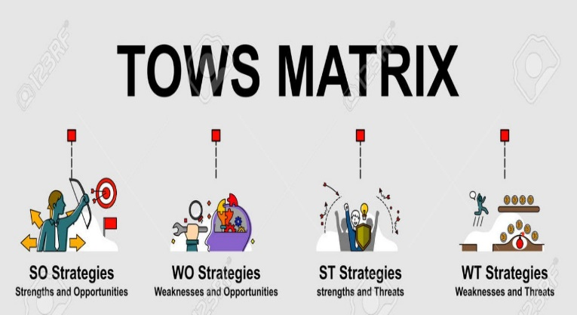

**Data Driven Decision Making**



**Data Dynamos**

For HR Data Analysis

**TOWS Analysis Report for Human Resources**

**1. Introduction**

This report aims to analyze employee data using the **TOWS Matrix**, which helps in formulating strategies based on strengths, weaknesses, opportunities, and threats derived from the data. The analysis is based on data including attrition rates, job evaluations, education levels, and years of experience, providing a comprehensive overview of the company's current status.

**2. TOWS Analysis**

**First: SWOT Analysis**

**✅ Strengths (S):**

* Competitive salaries for some employees compared to the market.
* A significant number of employees have long experience, enhancing company stability.
* Promotion opportunities are available based on employee performance and experience level.
* Flexibility in internal travel, facilitating knowledge transfer between branches.
* Stability in productivity levels among high-performing employees.

**❌ Weaknesses (W):**

* High employee turnover (attrition), increasing recruitment costs.
* Weak incentive programs such as stock options.
* Some employees experience long delays in promotions despite good performance.
* Large salary disparities among employees in the same roles.
* Lack of professional training and development opportunities.

**🌍 Opportunities (O):**

* Possibility of improving training and development programs based on performance evaluations.
* Enhancing financial incentives and promotions to increase job satisfaction.
* Offering remote work opportunities to boost productivity and reduce commuting.
* Leveraging technology to improve the work environment and increase efficiency.
* Expanding into new markets, creating opportunities to recruit new talent.

**⚠️ Threats (T):**

* Intense market competition for talent, leading to the loss of skilled employees.
* Varying levels of job satisfaction may negatively impact overall company performance.
* Rising recruitment and training costs due to high attrition rates.
* Increasing work pressures may affect job stability and productivity.
* New laws and regulations may impose additional requirements on the company.

**Second: TOWS Matrix & Strategic Actions**

|  |  |  |
| --- | --- | --- |
| Factors | Opportunities (O) | Threats (T) |
| Strengths (S) | **SO Strategy**: |  |

1. Develop training programs to enhance skills based on evaluations.
2. Leverage competitive salaries to attract and retain talent.
3. Increase travel and job exchange opportunities to improve employee efficiency.

|  |  |  |
| --- | --- | --- |
| Factors | Opportunities (O) | Threats (T) |
| Strengths (S) |  | **ST Strategy**: |

1. Enhance job stability through long-term incentive policies.
2. Develop an attractive work environment to reduce external competition for skilled employees.
3. Improve promotion policies to ensure high-performing employees stay.

|  |  |  |
| --- | --- | --- |
| Factors | Opportunities (O) | Threats (T) |
| Strengths (S) |  |  |
| Weaknesses (W) | **WO Strategy**: |  |

1. Improve financial incentives and rewards to create a more competitive work environment.
2. Implement sustainable professional development plans to empower employees.
3. Enhance work-life balance through flexible policies.

|  |  |  |
| --- | --- | --- |
| Factors | Opportunities (O) | Threats (T) |
| Strengths (S) |  |  |
| Weaknesses (W) |  | **WT Strategy**: |

1. Reduce attrition rates through work environment improvements and stress reduction initiatives.
2. Review recruitment and retention policies to ensure workforce stability.
3. Introduce psychological support and career counseling programs to reduce job stress and increase productivity.

**3. Strategic Recommendations**

1. **Enhance training and development programs** by offering specialized courses for each job category.
2. **Restructure the incentive system** to include financial rewards and stock options for high performers.
3. **Improve the work environment** by implementing flexible work policies and increasing promotion opportunities.
4. **Conduct periodic surveys** to measure employee satisfaction and address issues promptly.
5. **Develop talent retention policies** by reviewing employment contracts and improving workplace conditions.
6. **Regularly analyze job performance data** to identify high-potential employees and empower them.
7. **Promote a culture of recognition and reward** by acknowledging individual and team achievements.
8. **Leverage technology** to improve HR management and automate administrative processes.

**4. Conclusion**

This report highlights significant opportunities to improve the work environment and increase employee stability by leveraging strengths and developing policies to mitigate threats. By implementing the outlined strategies, the company can enhance its competitive edge and reduce employee turnover.

**🚀 Next Step:** Execute improvement plans and conduct regular performance evaluations to ensure the achievement of strategic goals and boost employee satisfaction and retention.



|  |
| --- |
| **Data Dynamos** |